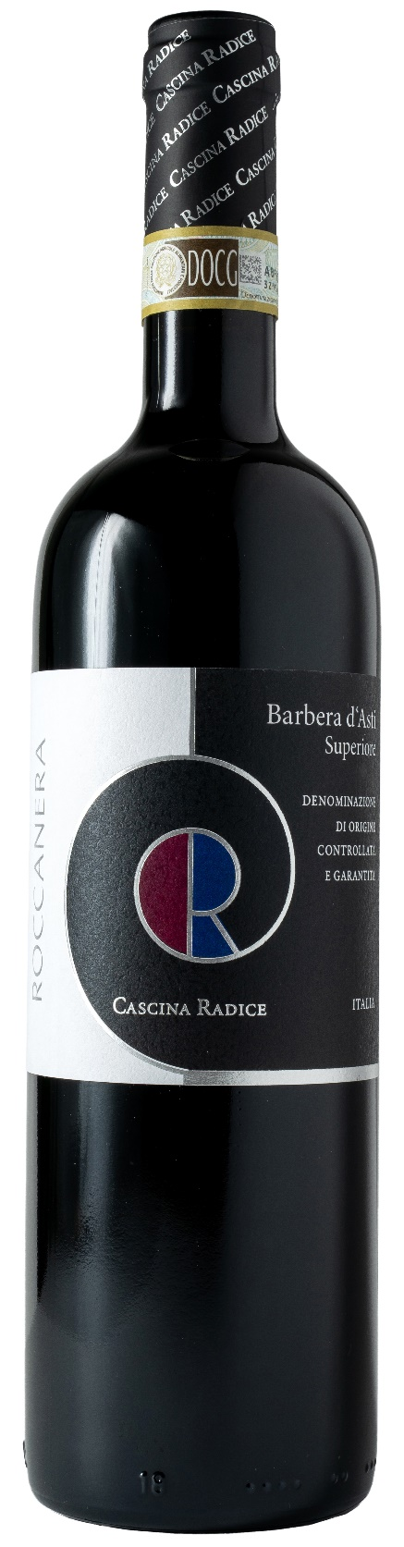
BARBERA D’ASTI SUP. DOCG – ROCCANERA

Grape: Barbera 100%
Alc. Vol.%: 15
Vintage: 2022
Residual sugar g/l: 2,0
Total acidity g/l: 6,0
Region: Piedmont
Production zone: Vineyards in the village of Moasca (Asti)
Capacity: 750ml

CHARACTERISTICS

Vinification: Traditional peel maceration for 12-14 days followed by fermentation in oak vats
Aging: 16 months in barrique, 6 months in bottle
Yield per ha: 9000kg
Colour: Strong red with purple reflections
Bouquet: Elegant and complex with notes of wood berries and vanilla
Flavour: Dry, harmonious, strong with a long lasting finish

SERVING SUGGESTIONS

Best with game, red meat and poultry as well as with ripe cheese.
Serving temperature 18°C, to be decanted.
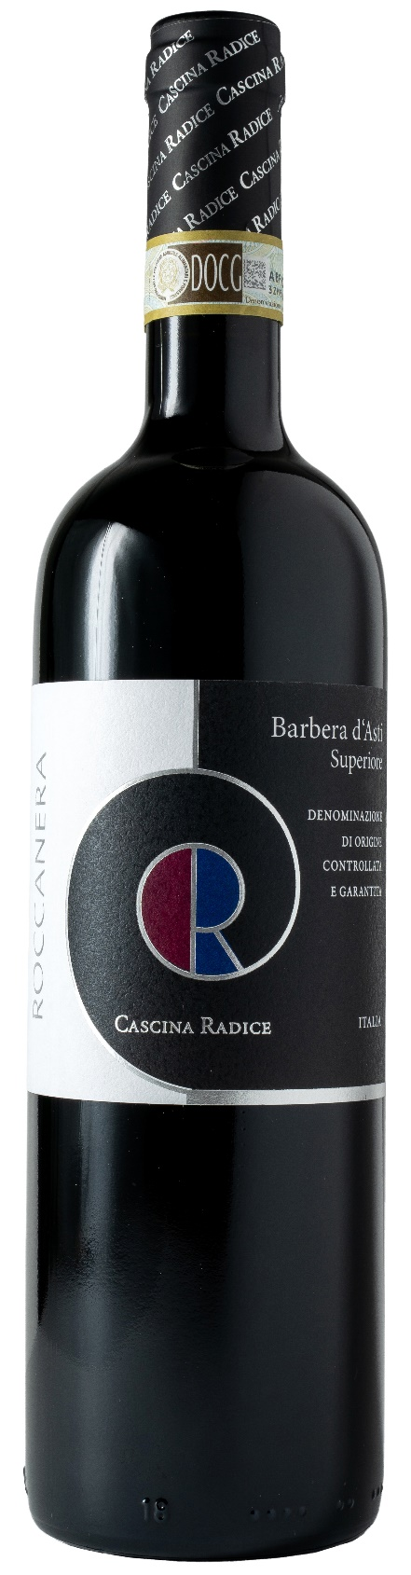
TECHNICAL INFORMATION / PALLETIZING

Size 750ml:
Article Nr. V02005A
GTIN-13 bottle 8017868003687
GTIN-13 carton 8017868002192
Closure Cork
Bottles / carton 6 bottles
Pallet size 80x120cm
Cartons/layer 10
Cartons/pallet 80
Kg/carton 8,2
Kg/pallet 680

Contains sulphites
GMO Free
Revisione 01. 17.07.2024

